Task 5

Automated Security Auditing & Scripting

Exploit:

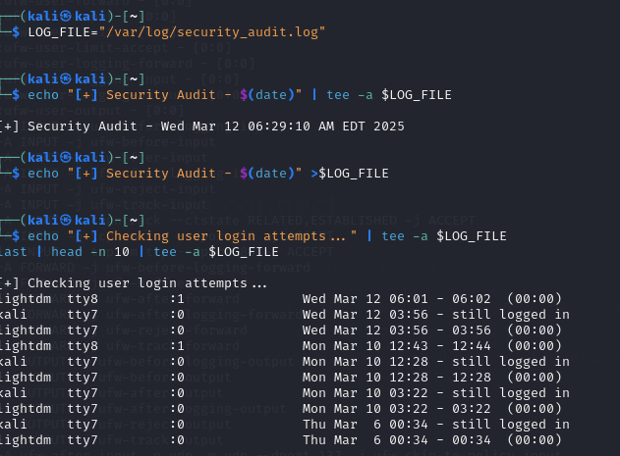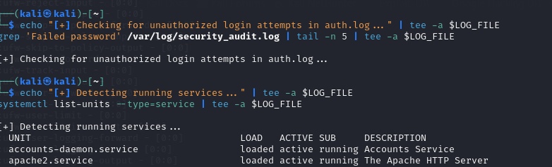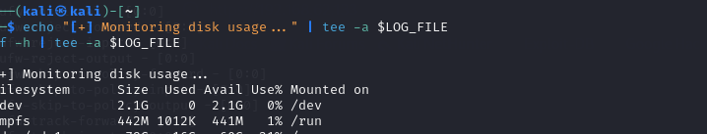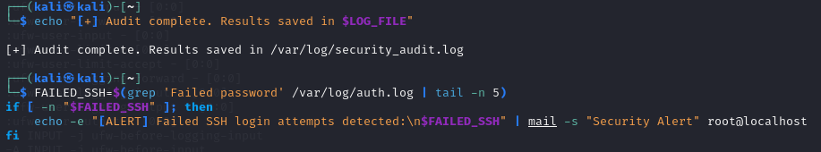

We generate a script as an example exploitation scenario which may involve identifying weak accounts from the previous output, such as old or inactive accounts. Additionally, detecting unused or vulnerable services through systemctl can reveal potential entry points for attackers.

Mitigation:

To automate proactive monitoring with cron, add the following line to your cron jobs:

> 0 * * * * /path/to/system_monitoring.sh

Purpose:

This configuration schedules the script to run hourly, ensuring consistent system monitoring.

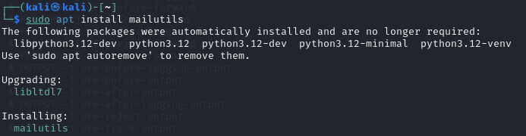

For enhanced security, implement email alerts for unauthorized SSH attempts. First, ensure mailutils is installed using the command: sudo apt install mailutils This solution improves your system's security posture by providing timely notifications and valuable insights into potential attack vectors.